Evidence for the PDA in software development

I&T Implementation and Testing Unit

Benjamin Bowen

Cohort E17

IT 1

Take a screenshot of an example of encapsulation in a program.



The fields for the class are private so cannot be accessed directly, but there are methods that allow them to be accessed.

IT 2

Take a screenshot of the use of Inheritance in a program. Take screenshots of:

● A Class



● A Class that inherits from the previous class

The Bedroom class is the subclass of the Room class. Apart from name, the information from the fields comes from the enum of the bedroom type.



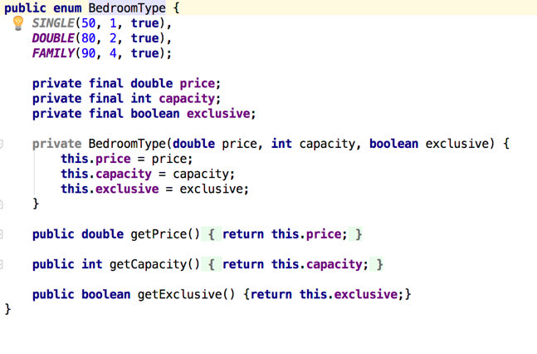

Show test of one of the inherited fields.

● An Object in the inherited class



● A Method that uses the information inherited from another class.

IT 3

Function that searches data

The result of the function running

This function finds all the transactions for a particular shop.

Initially my table of transactions is:

After the function has been run the new table is:

IT 4

Functions that sort data

The result of the function running

The function orders the transactions by date with the latest in time appearing at the top of the list and limits the table to only show five results

The result of running the function shows five results with the latest at the top:

IT 5

An array in a function

A function that uses the array

The result of the function running

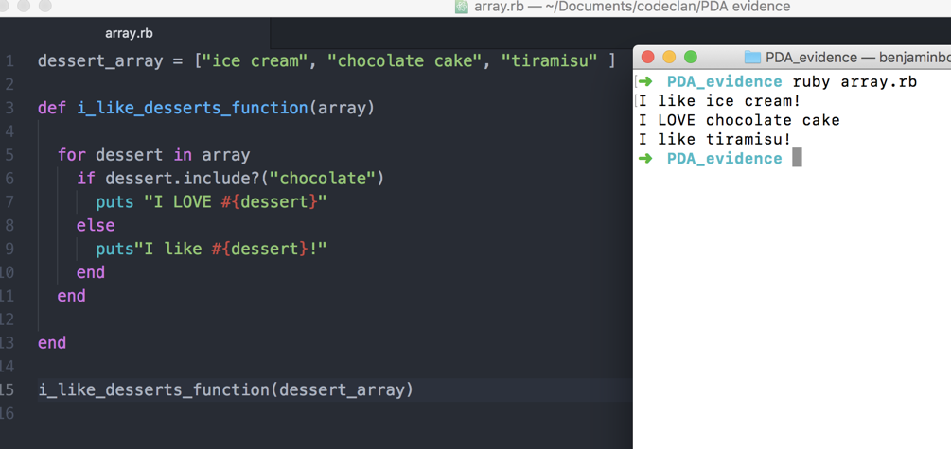

IT 6

A hash in a program

A function that uses a hash

The result of the function running

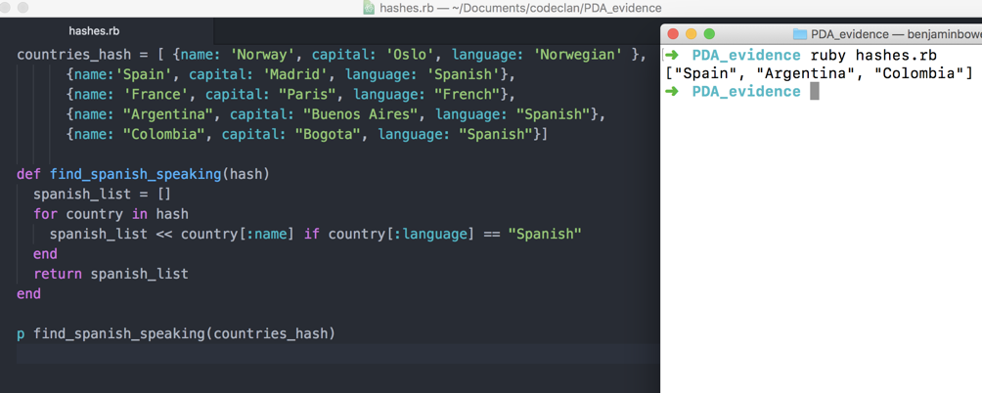

IT 7

Demonstrate the use of Polymorphism in a program.

Both the Cat and Dog classes are subclasses of Animal. There is a roar method in Animal which is overridden in both the Cat and Dog class:

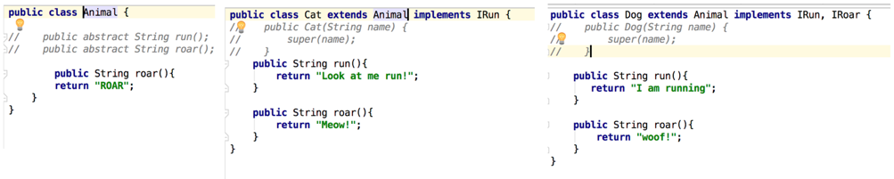

An ArrayList of Animals is formed and looped through, with the roar method called on each. Whilst the Cat and Dog are Animals, their specific roar method is called and seen in the output.

Change to use an interface rather than inheritance.

